FIG GARDEN FIRE PROTECTION DISTRICT
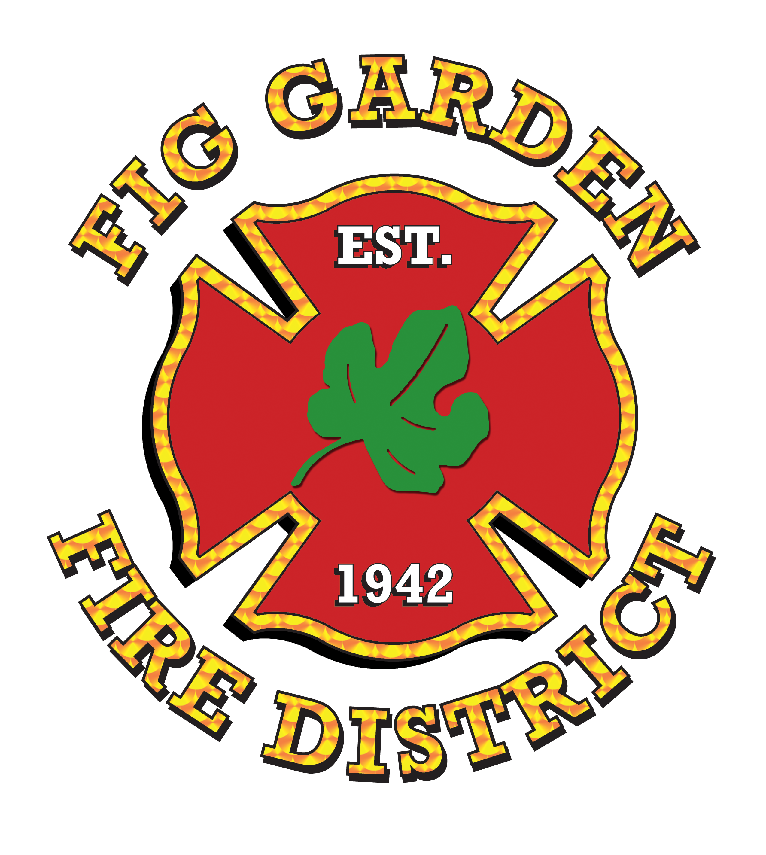
Fire Headquarters
911 H Street
Fresno, California 93721
(559) 621-4199 FAX (559) 498-4261

FIG GARDEN FIRE PROTECTION DISTRICT
Board of Directors – Regular Meeting Minutes
March 14, 2016 – 5:30 p.m.
Fire Headquarters
911 H Street

DIRECTORS PRESENT: Vernie Rogers, Louis Linney & Oney Durney
DIRECTORS ABSENT: none
CITY OF FRESNO: Fire Chief, Kerri L Donis; Business Manager, Mike Getty and Management Analyst, Elida Rubio
OTHERS: Website Designer, Gavin Haubelt

The meeting was called to order at 5:32 p.m. by President Rogers.

Board of Directors Minutes – January 12, 2016
- President Rogers motioned to adopt the minutes of January 12, 2016; seconded by Director Durney; motion carried.

Public Commentary
- None

Board Member Comments/Updates
- Director Durney and Chief Donis will be attending the FGHOA meeting on Wednesday, March 16th, 6pm at the Swimming Racquetball Facility.

Website Updates
- Website Designer still needs pictures and bios for each board member
- Need Fig Garden Stats for the year. (what was used for the FGHOA (last year’s mailers)
- Requesting more old pictures of Station 20
- Need announcements for the front page
- Need a picture of the rig for cover page
- Gavin will be updating the web page as needed. Quarterly billings will be paid.
- Add CFD creation (?)

Weed Abatement Program
- Weed abatement concerns:
  - 652 E Indianapolis
  - All Semis Properties are weed infested. Eight properties which include Sunset property need to be inspected for weed abatement
  - Commercial property with chain link across, east of 777 E Shaw
- Staff presented Resolution 2016-01 for the annual weed abatement process.
- Director Linney motioned to adopt Resolution 2016-01 as presented, seconded by Director Durney; motion carried.

Station 20 Remodel Update
- 2nd set of plans will be produced from Dale Rutherford. Once plans are complete the RFP will be the next step in the process before the construction can begin.
- Two options for construction is the bidding from JOC or do our own RFP for a construction management company to handle.
- Director Linney asked, once plans are completed if a dual RFP process be done simultaneously?
- Timeline is still 60 days for the plans to be complete. After, another 60-90 for bidding of RFP.

Policy and Guidelines for Station 20 Facility use
- Staff presented the old policies that were hanging on the wall at the Fig Garden conference room. Had board members review and make any changes if needed.
- Add policy to website once updated.
- Ask Nancy Jenner for a boiler plate of certificate of insurance for all proposed reservation.
- Staff will draft policy, and adopt; pending further notification until the completion of station remodel there will be no outside use.

Moving 2016 board member meeting back to Station 20
- Director Linney requested to move back to station 20 until the remodel until it’s physically not accessible.
- Next meeting scheduled May 31st will be held at station 20.

Financial Update/Authorization Documents
- Business Manager Getty updated the Board on activity and cash balances for the seven months ended February 29, 2016.
- Management Analyst Rubio presented payment vouchers for signature.

Fire Chief Updates
- Chief Donis reviewed the call statistics through 2/29/16.
- Funeral arrangements for Captain Lopez
- Award & Promotion Ceremony scheduled 3/29/16
- Promote internal candidate to Deputy Chief
- Promote internal candidate to Battalion Chief
- Budget deliberations will begin this month
- Applied for SAFER 2015

Notice of Public Hearing for Majority Protests – Closed Session
  - Director Linney motioned to cancel closed session and end closed session at 6:30pm; seconded by President Rogers; motion carried.

9. Scheduled Meeting Dates
- Appointments for the following dates forwarded to all Directors:
  - May 31, 2016
  - September 13, 2016
  - December 7, 2016 (tentative)

10. Adjournment
- President Rogers motioned to adjourn the meeting at 6:37 p.m. and; seconded by Director Linney; motion carried.

